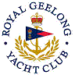 | Royal Geelong Yacht Club Inc.  Est 1859
Trophy Deed of Gift.

Trophy: | House Committee Perpetual Shield
Presented by: | “House” Committee
Date: | 1948
For: | “A” Class Aggregate Winner
Remarks / Revisions | No Longer awarded
Editor’s Note
Prior to the Club appointing paid staff, the operations of the Club were overseen by various sub-committees, one of which was the ‘House Committee’. Its purpose was to manage the operations of the ‘House’ including social functions and Bar.. Most of its activities are now performed by the Front-of-House manager.

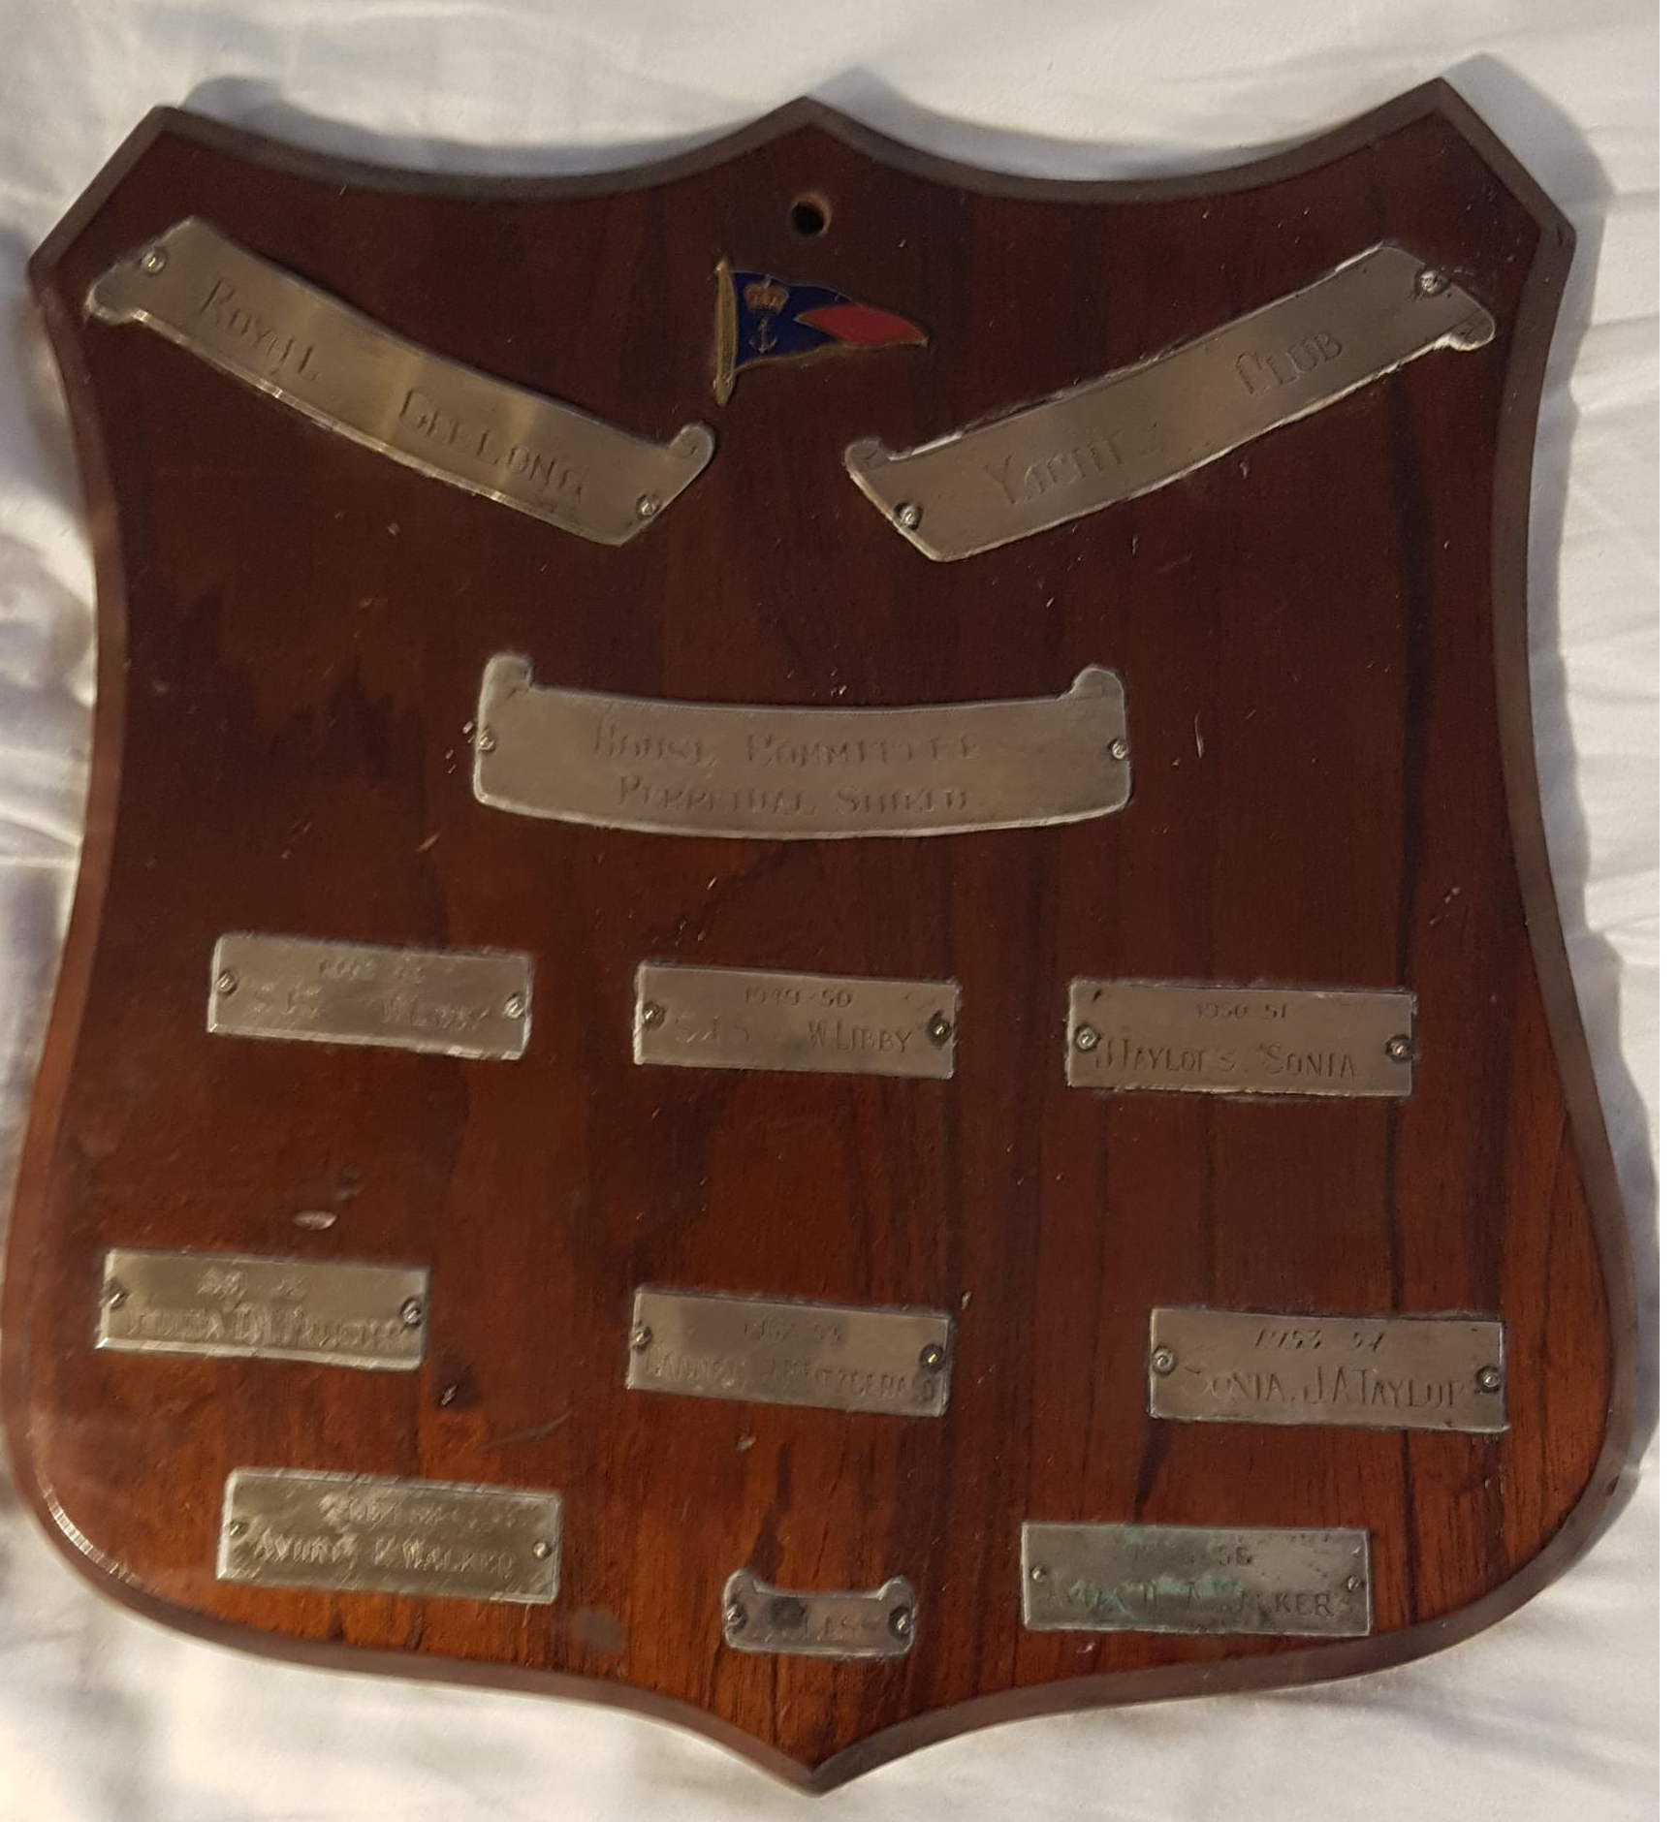

Recipients
1948-1949 | S. J. S | W. Libby
1949-1950 | S. J. S | W. Libby
1950-1951 | Sonia | J. A. Taylor
1951-1952 | Yeulba | O. N. Mcallister
1952-1953 | Gannet | J. R. Fitzgerald
1953-1954 | Sonia | J. A. Taylor
1954-1955 | Avion | E. Walker
1955-1956 | Avion II | A. Walker

